eSTEAM Activities
http://steam-mccracken.weebly.com/
Monday, October 3rd
- Who are the big thinkers in digital media and how did they arrive at their products? This video will help explain the thinking behind the creation of certain products.

- ISTE STEAM Standard:
http://www.iste.org/standards/standards/for-students-2016
Computational Thinker: Students develop and employ strategic strategies for understanding and solving problems in ways that leverage the power of technological methods to develop and test solutions.
- Video: (9:15 min)
https://youtu.be/pvAsqPbz9Ro

- Questions:
  - Why is creativity and play important for social media creation?
  - How could knowing coding and having a computer science background transform your life?

Tuesday, October 4th
- How does 3D-printing work? From making tools onboard the International Space Station to building bionic hands, the first stage of this revolutionary manufacturing process might surprise you...

- ISTE STEAM Standard:
Knowledge Constructor:
3a. Students plan and employ effective research strategies to locate information and resources for their intellectual or creative pursuits.
3b. Students curate information from digital resources using a variety of tools and methods to create collections of artifacts that demonstrate meaningful connections or conclusions.
- Video: Intro to 3D Printing: From Plants to Prosthetics: The Science of 3D Printing.

https://youtu.be/H0jqosCHJeg

- Questions:
  - How does 3D printing enhance printing in general?
  - What would be useful for you to print in your daily life?

Monday & Tuesday, October 11th & 12th
Coastal Kingdom (River of Words)

1. Take a trip through the salt marsh, across vast rivers of Spartina grass, pluff mud flats and nutrient-rich waters to find out why our marsh is important for the Lowcountry.
How might understanding the Lowcountry environment impact our work in River of Words?
2. Ocean Literacy Standards:
#5. The ocean supports a great diversity of life and ecosystems.
Ocean habitats are defined by environmental factors. Due to interactions of abiotic factors such as salinity, temperature, oxygen, pH, light, nutrients, pressure, substrate and circulation, ocean life is not evenly distributed temporally or spatially, i.e., it is "patchy".
Some regions of the ocean support more diverse and abundant life than anywhere on Earth, while much of the ocean is considered a desert.
3. Coastal Kingdom video (salt marsh):
http://www.coastalkingdom.com/episodes/the-salt-marsh
4. Questions:
a. Why is it important to leave a buffer of grasses, shrubs and trees between your yard and the marsh?
b. How does the Lowcountry salt marsh “feed” our art scene in Beaufort?
Monday & Tuesday, Oct. 17th & 18th
- Resonant Rings: This activity graphically demonstrates that objects of different sizes and stiffness tend to vibrate at different frequencies.

- SC Science Standard:
- Standard 6.S.1: The student will use the science and engineering practices, including the processes and skills of scientific inquiry, to develop understandings of science content.
- 6.S.1A.2 Develop, use, and refine models to (1) understand or represent phenomena, processes, and relationships, (2) test devices or solutions, or (3) communicate ideas to others.

- Exploratorium video: http://www.exploratorium.edu/snacks/resonant-rings
Audio: NPR, Ted Talk, How I Built This
http://www.npr.org/2010/01/14/122547242/haitis-buildings-werent-fit-to-withstand-quakes
- Questions:
  - Why do the rings have different resonant frequencies if they are shaken, and what does that mean for buildings in an earthquake?
  - How do the circles affect the building’s resonant frequencies?

Monday, October 24th
1. The project has created the world’s first live tweeting honeybees, @citybeehive and @countrybeehive, in an initiative that aims to engage people with the lives of the bees through innovative use of technology and social media. Both hives will tweet, in character, about the daily activity of the bees, triggered by live data collected and analyzed as part of the scientific research looking at the impact of city living on honeybee colonies.
2. SC Science Standards:
6.L.4B.2 Obtain and communicate information to explain how the structural adaptations and processes of animals allow for defense, movement, or resource obtainment.
6.L.4B.3 Construct explanations of how animal responses (including hibernation, migration, grouping, and courtship) to environmental stimuli allow them to survive and reproduce.
3. Honeybee video & info. link: http://www.animateit.org.uk/bees/home
https://www.at-bristol.org.uk/bees

4. Questions:
a. Can you see any differences between the city and the country honeybee?
b. How does McCracken become a bee pollinator friendly school?
http://www.beebristol.org/
Answer: Think about native wildflower meadows.
http://www.beebristol.org/conservation

Tuesday, October 25th

1. How does interpretive dance help honeybees locate food and communicate it to the colony?
2. SC Science Standard:
6.L.4B.2 Obtain and communicate information to explain how the structural adaptations and processes of animals allow for defense, movement, or resource obtainment.
6.L.4B.3 Construct explanations of how animal responses (including hibernation, migration, grouping, and courtship) to environmental stimuli allow them to survive and reproduce.
SC Dance Standard:
Standard 4: The student [or bee] will demonstrate and apply critical, creative, and analytic thinking in response to dance.
Indicators
D7-4.1 Create and demonstrate multiple solutions to movement problems; identify the most interesting solutions and explain his or her choices.
3. Video: https://youtu.be/2S-ozxpIrdI
4. Questions:
a. What is the research looking at and what is their baseline prediction?
The research is investigating whether human activity (e.g. pollution) has an effect on bee behavior. A hive in rural Langford is being used as a comparison. Both hives contain a bee-counter, which measure bee activity, an air quality sensor, a weather station and an electric field monitor.

It is predicted that human activity will have an effect on urban bees as a result of 7 day cycles in air quality, due to pollution caused by Monday–Friday commuter traffic.

b. What happens when the health of honeybees is harmed?
https://www.theguardian.com/environment/2012/mar/29/crop-pesticides-honeybee-decline

Monday, October 31st

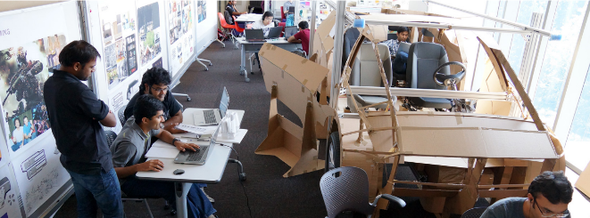

1. Overview: How does a student get access to training in a career in high tech manufacturing at BMW, Michelin and/or further study at CUICAR?

2. ISTE STEAM Standards:
(Here we are watching this standard in progress.)
Communication and Collaboration: Contribute to project teams to produce original works or solve problems.

3. Video: http://www.bmwusfactory.com/student-programs/technical-and-community-college-students/scholars-program/

4. Questions:
a. What type of credentials will you need to enter such a program?

b. How can specific classes available at McCracken help students reach this goal?

Flyers for students:
BMW flyer:
https://www.bmwusfactory.com/wp-content/uploads/2015/01/Scholar_Flyer_2016-Approved.pdf

Michelin flyer:
file:///C:/Users/wlb8839/Downloads/Michelin%20Scholarfinal%20ARchecked.pdf
and Michelin Scholars overview:
http://www.gvltec.edu/Michelin-scholars/

and Clemson University’s ICAR
http://cuicar.com/education/

The Department of Automotive Engineering is part of Clemson University’s College of Engineering and Science. Their diverse student body shares two things – a hunger for knowledge and a passion for the car. CUICAR is a magnet for the best and brightest, and a 'go-to' place for world-class talent.

Tuesday, November 1st

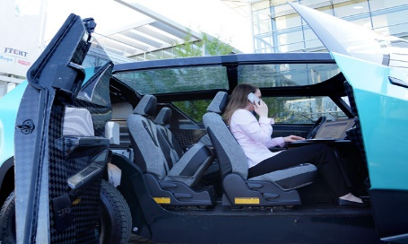

1. Want to see the new bSPOKE car that Clemson built? It is marketed as a personal urban mobility concept that adapts to the needs of Gen Z.

Born 1995 and later, Gen Z is society’s first true “digital natives”. Constant multi-tasking and connectedness blurs the lines of work and life. The ability to work, study, play and relax whenever and whenever demands transportation to supplement life’s experiences beyond traveling from A to B. The vehicle is targeted for introduction to the U.S. market in 2020, catering equally to both males and females.

2. ISTE STEAM Standards:
(Here we are watching this standard in progress.)
Creativity and Innovation: Students demonstrate creative thinking, construct knowledge, and develop innovative products and processes using technology.

3. Video:
a. Time elapsed (really fun):
https://youtu.be/5Ar0ILyjkB8?list=PLzIRcL2rgOD-jQpFKTESf2eKpe_BKWK5b

b. http://cuicardeeporange.com/project/do6
(can explore w/students or have them use their tablets – great information)

4. Questions:

a. What is the Deep Orange mission?
Deep Orange realizes its core beliefs through a hands-on, real-world, collaborative educational environment that stimulates transversal working and holistic thinking from entry into the automotive engineering program until graduation.

Deep Orange stimulates engineering creativity through collaboration with transportation design students. Industry partners are invited to mentor students on industry-focused engineering practices and subject matter related to developing technology innovations throughout the educational experience.

b. Why would it be important to educate SC students to be future innovators and engineering leaders who develop sustainable mobility solutions balancing environmental, social and economic aspects?

Monday, November 7th

1. Andy Warhol: Green Coca-Cola Bottles was created the year (1962) that Andy Warhol developed his pioneering silkscreen technique, which allowed him to produce his paintings through a mechanical process that paralleled his use of mass culture subjects.

2. Kennedy Center (Federal) Art Standards, Visual Arts, Standard 5:
- Students compare multiple purposes for creating works of art
- Students analyze contemporary and historic meanings in specific artworks through cultural and aesthetic inquiry
3. Video: https://www.khanacademy.org/humanities/art-1010/pop/v/andy-warhol-campbell-s-soup-cans-why-is-this-art (7.08 mins)

4. Questions:
a. Per Steven Zucker, why have certain works of art have become more or less important over time and long after the artist's era has ended?

b. Can beauty be found in the industrial world? Why or why not?

Tuesday, November 8th
Election Day

Monday & Tuesday, November 14th & 15th
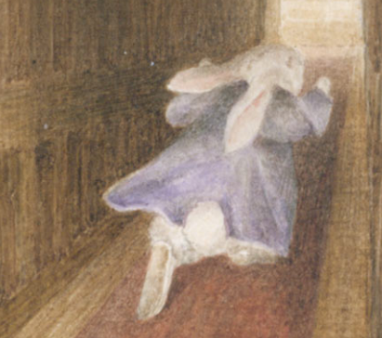

1. Creative Writing & Illustrations
Beatrix Potter’s extraordinary flair for storytelling distinguishes her from many other children’s book illustrators of the ‘golden age’ who, rather than writing their own stories, illustrated traditional fairy and folk tales, fables and nursery rhymes (for source, see www.vam.ac.uk). She was both an artist and a naturalist.

See this rich source for Potter’s work and influences:
http://www.vam.ac.uk/content/articles/b/beatrix-potter-the-art-of-illustrating/

Read the section on Caldecott & later on Beatrix’s own work learning to illustrate.

2. SC Art Standards/Visual Arts:
VA7-6.3 Identify specific visual arts careers and describe the knowledge and skills that one needs for these careers.

3. Video: Play by hitting the bunny picture (converted video) or at
http://www.peterrabbit.com/adults/ and look for Beatrix Potter with Patricia Routledge.

And
Scroll thru these illustrations w/students (see center):
http://www.peterrabbit.com/about-beatrix-potter/

EXTRAS:
Movie trailer:
https://www.awesomestories.com/media/user/5946e474d1.mp4

Older video:
https://www.awesomestories.com/asset/view/Beatrix-Potter-The-World-of-Peter-Rabbit-Part-1

4. Questions:
1. What made Beatrix Potter an exceptional naturalist?

Beatrix Potter studied flora and fungi in her local environment. She was fascinated by nature and often carried a sketchbook with her, incorporating these studies into her art. She is now credited with making significant discoveries and studies around fungi (from Beatrix Potter teaching pack/Resources)

2. What makes Beatrix Potter a master illustrator?

In order to replicate the correct postures and physical features of animals, Beatrix and Randolph Caldecott (an exceptional illustrator) examined and sketched stuffed specimens and skeletons in their local museums. Caldecott’s home at 46 Great Russell Street was conveniently located opposite the British Museum. Beatrix’s home at 2 Bolton Gardens was closer to the Natural History Museum in South Kensington. She described the museum as ‘the quietest place I know – and the most awkward’ (journal entry, Friday 20th December 1895).

Beatrix’s animals, like those of Caldecott, are full of exuberance and energy. Both Beatrix and Caldecott mastered ‘the art of leaving out’. They created depth and background with a few skillfully executed lines representing water, raindrops and river plants. Their drawings, unlike the densely decorated pages of Walter Crane’s picture books, seem to float on the page unimpeded by frames or borders (see source at http://www.vam.ac.uk/content/articles/b/beatrix-potter-the-art-of-illustrating/).

Monday & Tuesday, November 21st & 22nd
Thanksgiving Week
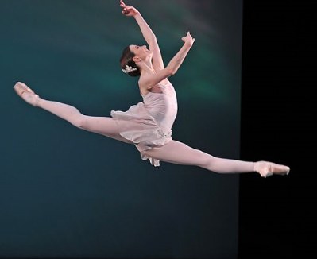

1. What is the life of a ballerina? We’ll watch two videos, including one star from the Royal Ballet who has “made it” and another star from SC Governor’s School for the Arts and Humanities who is rising. Notice that ballet involves the intricate interplay of art and physics.

2. Kennedy Center National Core Dance Standard 1: Students demonstrate increasing kinesthetic awareness, concentration, and focus in performing movement skills

3. Video: http://www.bing.com/videos/search?q=royal+ballet+students+videos&view=detail&mid=5BC04C3FC66B2FD1D6C45BC04C3FC66B2FD1D6C4&FORM=VIRE

And

http://www.bing.com/videos/search?q=sc+governors+school+for+the+arts+ballet+video&view=detail&mid=2F92456727690FDD8E432F92456727690FDD8E43&FORM=VIRE

Schools for ballet:
Idyllwild Dance:
http://www.idyllwildarts.org/page.cfm?p=849
and
SC Governors School for the Arts and Humanities
http://www.scgsah.org/dance.php

4. Questions:
a. How does a ballerina prepare their shoes?
https://artsedge.kennedy-center.org/students/features/gear/pointe-shoe (great video - 3:12 mins.)

b. Would exposure to this art form help sway students to pursue it as a career?

Monday & Tuesday, November 28th & November 29th -- Hands on Activity

1. Whirling Watcher: A series of slits moving rapidly past your eye allows you to see images in short bursts. Such rapid but fragmented views of moving objects can make the objects appear to jerk along, change speed, or even move backward.

http://www.exploratorium.edu/snacks/whirling-watcher
2. Standards:
3. Video:
4. Hands-on activity (no question sets today)

Monday & Tuesday, December 5 & 6: Art Institute of Chicago>Play with Art>Portrait Play & Mask Maker

1. Students use laptops to match heads in paintings using Monday, Dec. 5th, Play with Art>Portrait Play. They should click “Play Another” to see the next painting. Also try Mask Maker and build a mask using 5 animals. On Tuesday, Dec. 6th use Play with Art>Match Up>Match Texture, Shape & Sound

2. Standards: Use Elements of Visual Art sheet (laminated/given thru PLC)

3. Video: Play with Arts>Portrait Play & Mask Maker http://www.artic.edu/aic/education/CC/

4. Hands-on activity w/computer game

Monday, December 12th – Getty Museum, Watercolor Masters

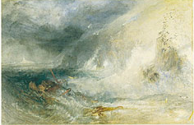

1. Watercolor Techniques using Homer, Delacroix, and Turner’s paintings. This page illustrates four of the most common watercolor techniques—blotting, scraping, wet-on-wet, and dry brush.

http://www.getty.edu/art/exhibitions/prismatic/watercolor_techniques.html

2. SC Visual Arts Standards: VA8-1.1 Identify the materials, techniques, and processes used in a variety of artworks.

VA8-1.2 Describe ways that different materials, techniques, and processes evoke different responses in one who is creating or viewing artworks.

3. Video: Click “Listen to a Discussion of this Image” under each of the 3 paintings for each of the 3 audios, and here’s the first one:
http://www.getty.edu/art/exhibitions/prismatic/audio_00025001.html

4. Questions:
a. What are the differences in watercolor techniques as used by these three artists: Turner, Homer and Delacroix?
b. How does understanding the method or technique used increase your understanding and interest in the piece of art?

Tuesday, December 13th - Getty Museum, Four Centuries of Perspective

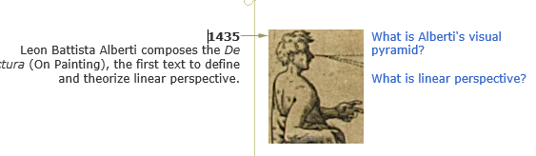

1. Have students use their laptop for A Timeline: Four Centuries of Perspective. four centuries of experimentation in perspective theory and spatial illusion. (Make sure to click on the drawings within the timeline.)

2. Standards: Use Elements of Visual Art/PLC handout

3. Video: http://www.getty.edu/art/exhibitions/geometry/timeline.html

4. Questions: a. What did you learn about linear perspective and the ways this perspective goes awry?
b. What is the underlying geometry in Alberti's visual pyramid? (Make sure to click on the drawings).

Monday, December 19th, Learning Formal Analysis/Paintings/Landscapes

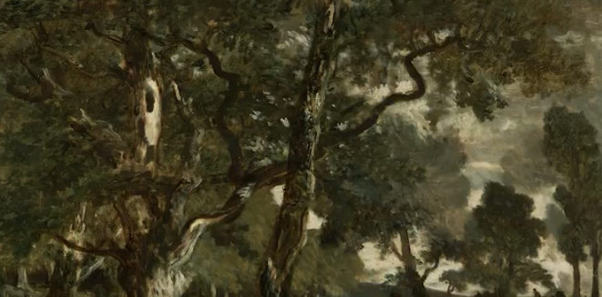

1. Learn formal analysis of landscape paintings as you compare and contrast two artworks related by genre by Nicolas Poussin.
2. SC Visual Art Standards: Using Structure and Function: VA8-2.1 Identify the elements and principles of design used in a particular work of visual art and describe the ways in which these characteristics express the artist’s ideas and affect the viewer.
3. Video: https://www.youtube.com/watch?v=AIbTrG-SlDE&feature=youtu.be
4. Questions:
a. Define some of the key elements of landscape paintings.
b. How well are these elements used in the two paintings you are viewing?

Tuesday, Dec. 20th: Catch-up Day on eSTEAM activities. If you missed one or more for other activities, then use this time to go back and review it. Merry Christmas and/or Happy Holidays.

Monday & Tuesday, January 9th & 10th -- Art & Context

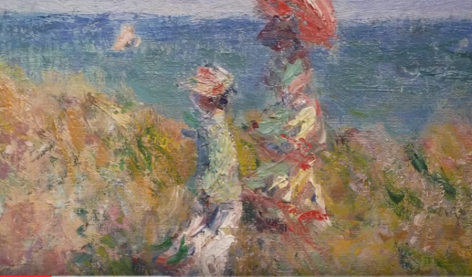

1. Impressionism, including analyzing abstract art in which artists examined what light looked like at specific times on the canvas. This period and artist are tied to Russia’s history and the idea of utopia. Viewing Monet's Cliff Walk and Malevich's Suprematist Composition: White on White.

2. Standards: VA8-2.4 Describe the ways that his or her use of organizational principles and expressive features evoke the ideas he or she intended to convey in a work of visual art.

3. Video: (10:26 mins) https://www.youtube.com/watch?v=2aUFB9hQncQ

4. Questions.
a). Is art an accumulation of the culture the artist lives in at the moment?
b). Why are the flat, tonal, square against a square composition of White on White important for this artist in considering how art changes the world?

Monday (Holiday) & Tuesday, January 17th – Salvador Dali, The Persistence of Memory, 1931

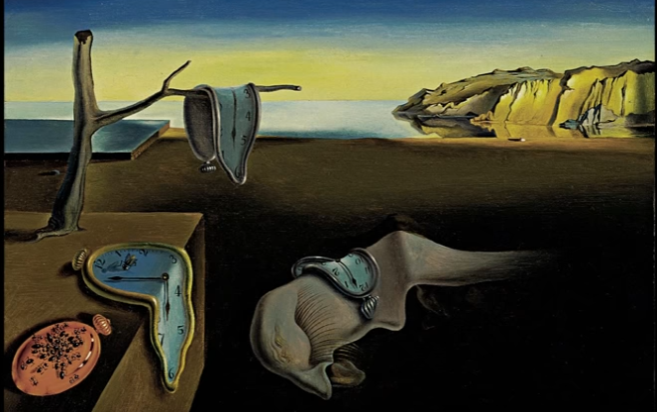

1. Exploration of the different forms of reality using Salvador Dali's work.

2. SC Visual Art Standards: Standard 2: The student will use composition and the elements and principles of design to communicate ideas.

3. Video: (6:27 mins) https://www.youtube.com/watch?v=6mp-fBJNQmU

4. Questions:
a. How does Dali create a dreamscape?
b. What makes Dali’s work unusual for the time period?

Monday & Tuesday, January 23rd and 24th – Federal Duck Stamp Competition

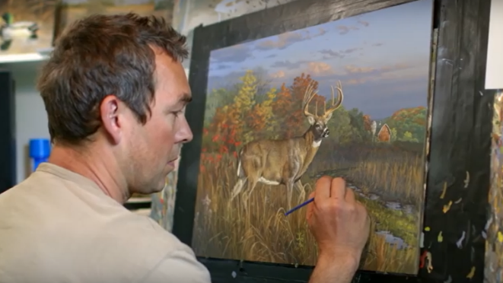

1. Did you know that each year, the federal government awards a duck stamp winner that all hunters must purchase to hunt ducks, and the artist can market their winning stamp for more than $1 million? AND, there is a Junior Duck Stamp competition for those of you who want to both protect the environment through conservation (duck stamps protect millions of acres) and learn how to go for the larger prize. It’s time to get your duck stamp groove on!

Federal Duck Stamp Website: https://www.fws.gov/birds/get-involved/duck-stamp.php
2. Standards: VA8-6.3 Identify specific visual arts careers and describe the knowledge and skills that one needs for these careers.

3. Video: (2:13 secs – click picture to play) http://www.bing.com/videos/search?q=you+tube+million+dollar+duck+stamp&view=detail&mid=C20EE14C2FB039E79DA5C20EE14C2FB039E79DA5&FORM=VIRE

4. Questions:
a. What skill set do you need to compete for the Junior Duck Stamp Prize?
b. Why is the duck stamp important for conservation?

Junior Duck Stamp Website:
https://www.fws.gov/birds/education/junior-duck-stamp-conservation-program.php

Monday & Tuesday, January 30th & 31st - Easy Programming for Students

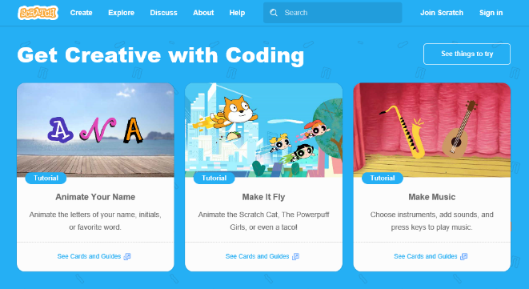

1. Do you want to begin coding? Here’s Scratch from the MIT Media Lab, which teaches the basics of programming without having to write code. Choose Animate Your Name>Tutorial, and use the NEXT button on the top right to scroll through a quick lesson. Brainstorm some ideas, and then get started creating your name in code.

Students will need their laptops.

2. ISTE Standards:
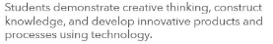

3. Video: https://scratch.mit.edu/ and Name Guide teacher directions at https://scratch.mit.edu/pdfs/guides/NameGuide.pdf

4. Hands-on Activity.

Monday, February 6th - Archibald Motley: Jazz Age Modernist (History + Visual Arts + Black History Month)

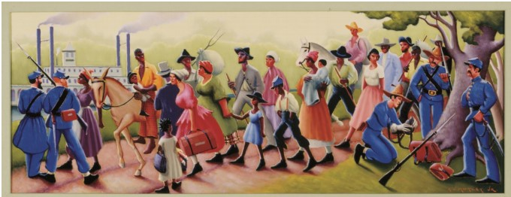

1. Archibald Motley created this painting as part of the Works Progress Administration’s Federal Art Project. As part of the New Deal, the WPA commissioned artists to create images celebrating the US and its people. Motley illustrates the Confederacy’s surrender to the Union army at Vicksburg, Mississippi by accentuating the strange, almost burlesque nature of that moment, imagining it in acidic colors, hobnail-boot fashions, and exaggerated characterizations. The aim of the Federal Art Project was to make American art more “truly American” and more in “touch with the people.” It sought to make art more accessible to the general public. This notion appealed to Motley, who wanted to make his works both aesthetically engaging and socially conscious.

2. Standards: Use Elements of Visual Art and the following handout: http://www.lacma.org/sites/default/files/MotleyImages.pdf

3. Video: Richard J. Powell, Professor of Art and Art History at Duke University and curator of this exhibition, describes and contextualizes Archibald Motley's distinct voice in portraying Chicago's burgeoning African-American culture around the 1930s.

http://www.lacma.org/video/archibald-motley-jazz-age-modernist

4. Questions for Mending Socks painting (see handout): Motley surrounded his grandmother with objects that were important to her. Make a list of the objects you see. A. What do these things suggest about his grandmother? B. How do you think Motley felt about his grandmother? C. What in the painting leads you to believe that?

Monday, February 13th – Amy Sillman (Painting + Space + Modernism)

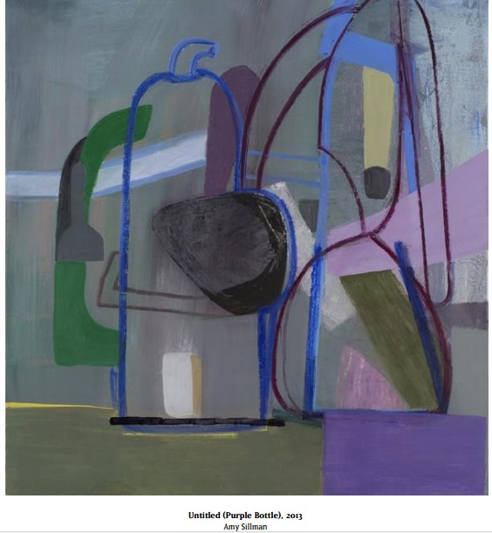

1. How is Amy Sillman’s work often characterized by an extended exploration of the formal principles of art, including such painterly concerns as figure, scale, and space?

Yet her materials and processes are quite varied— she works in pencil, crayon, watercolor, and collage, creating cartoons, diagrams, prints, and, recently, iPhone and iPad drawings and animations.

2. “Drawing is at the core of Sillman’s process; graphic gestures produce both light and heavy marks across her papers, canvases, or pages. An intuitive approach also informs her painting process, which can include multiple layers, constructing, deconstructing, and reconstructing space.”

“Many commentators have noted similarities between her work and that of twentieth-century painters such as Philip Guston and Richard Diebenkorn, as well as with that of sculptor Eva Hesse. Sillman also has spoken of the importance of Henri Matisse’s use of color, and Willem de Kooning’s use of transition and change in pictures that include dissolving figures. She has said that two extended trips to India fostered an interest in art that was intimate, narrative, mythic, and beautiful, and a residency in Italy allowed her to explore the flat spaces and imperfect perspective of early Renaissance painting.” Read more: http://www.lacma.org/sites/default/files/21cImages.pdf

2. SC Visual Arts Standards, Standard 1:
VA8-1.1 Identify the materials, techniques, and processes used in a variety of artworks. VA8-1.2 Describe ways that different materials, techniques, and processes evoke different responses in one who is creating or viewing artworks.

3. Recent Art Exhibits (scroll thru):
http://www.amysillman.com/pages/exhibitions.php

4. Questions:
What type of mark-making do you prefer? (Types of mark-making include drawing, painting, printmaking, collage, cartoons, digital animations, etc.) What artists and movements do you think have influenced you, and why?

Tuesday, February 14th – Makeup Day
Use this day to catchup on a previous eSTEAM activity.

Tuesday, February 21st – Frank Gehry, Contemporary Architect (Note: Monday, Feb. 20th - Best Practices Day)

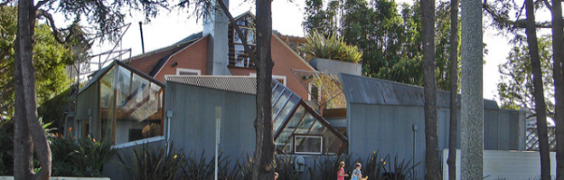

1. “The Gehry Residence in Santa Monica, Calif., has been selected for the 2012 AIA Twenty-five Year Award. Recognizing architectural design of enduring significance, the Twenty-five Year Award is conferred on a building that has stood the test of time for 25 to 35 years as an embodiment of architectural excellence. Projects must demonstrate excellence in function, in the distinguished execution of its original program, and in the creative aspects of its statement by today's standards.

A 1979 review by New York Times architecture critic Paul Goldberger, Hon. AIA, recognized the house as an extremely successful provocation - if not much more. He called the Gehry Residence the most significant new house in Southern California in years, admiring its central conceptual conceit: an old house wrapped in jagged panels of corrugated metal, creating a new band of patio-like indoor/outdoor space on three sides.” Article by Levent Ozler.
Read more: https://www.dexigner.com/news/24459
2. SC Visual Art Standards, Standard 4:

VA8-4.3 Demonstrate visual literacy by deconstructing works of visual art to identify and discuss the elements and principles of design that are used in them.

3. Video: Frank Gehry discusses the field of architecture and how he has changed over time. It also gives a brief look at his first project—his own house.

PBS NewsHour Video (7.28 mins)

https://www.youtube.com/watch?v=Gt1_BgCN6lU

See p. 1-2, Gehry Residence, and Walt Disney Concert Hall, p. 10-13, via pdf (below).

http://www.lacma.org/sites/default/files/GehryImagesQuestions.pdf
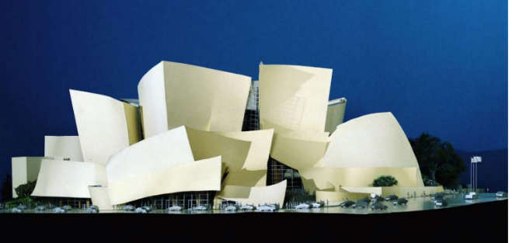
Frank Gehry Walt Disney Concert Hall—Project Model; Los Angeles, California, 1989–2003

4. Questions:
a. If you could design your own home, what features would you want? What would it look like?

b. Compare the Gehry Residence to the architect’s later work, the Walt Disney Concert Hall. What do they have in common? How do they differ? Some areas to consider include materials, purpose, location, client, style, and general appearance.

Monday & Tuesday, Feb. 27th & 28th – Frank Gehry, Architect: BBC Video & TEDTalk

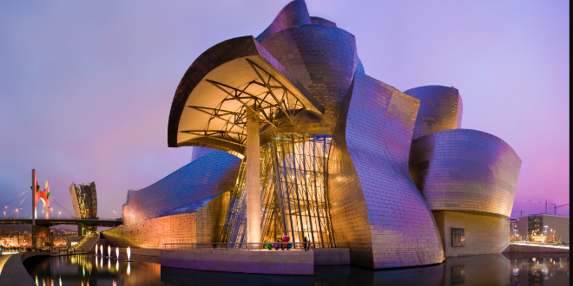
Frank Gehry, Guggenheim in Bilbao

1. The Guggenheim in is his greatest masterpiece and is inspired by Picasso’s cubist painting, The Accordionist. Please see the BBC film for an excellent discussion of his work (Video 1 – Click picture on website).

Video 2_TED Talk: In this entertaining discussion with Richard Saul Wurman, architect Frank Gehry gives TEDsters his take on the power of failure, his recent buildings, and the all-important "Then what?" factor. He also discusses the similarity between jazz and architecture.

Legendary architect Frank Gehry has created his own language of architecture, and created amazing buildings all over the world, such as the Guggenheim in Bilbao, the Walt Disney Concert Hall in LA, and Manhattan's new IAC building.

2. Kennedy Center (Federal) Art Standards, Visual Arts, Standard 5:
- Students compare multiple purposes for creating works of art
- Students analyze contemporary and/or historic meanings in specific artworks through cultural and aesthetic inquiry.
3. Video:

BBC Video (excellent video) – 1 hr. 10 mins & first 3 mins. is great.
https://www.youtube.com/watch?v=34tJ7JAjSW0

https://www.ted.com/talks/frank_gehry_asks_then_what (21 minutes)

4. Questions:
a. What makes Frank Gehry different than most architects?
b. How would you describe his work environment, and his methods of “composing” an architectural piece?

Monday & Tuesday, March 6th & 7th – Frank Lloyd Wright, Architect (Organic Design + Nature + Arts and Crafts – as seen thru Prairie House)

1. A central theme that pervades his architecture is a recurrent question in American culture: How do you balance the need for individual privacy with the attraction of community activity? Everyone craves periods of solitude, but in Wright's view, a human being develops fully only as a social creature.
(Read more: Smithsonian Magazine at http://www.smithsonianmag.com/history/the-triumph-of-frank-lloyd-wright-132535844/)

2. Video: Click the picture on the website for the 40 sec. clip.

Also, explore the website, Frank Lloyd Wright Trust at http://flwright.org/

See additional pictures from Mrs. Sullivan at Bluffton University, Ohio:

http://www.bluffton.edu/homepages/facstaff/sullivanm/index/wright/wrightindex.html#commercial

Project Based Learning Units in STEAM:
http://www.lacma.org/sites/default/files/ProjectBasedLearningUnitsSTEAM.pdf

Monday & Tuesday, March 13th & 14th – I. M. Pei, Architect

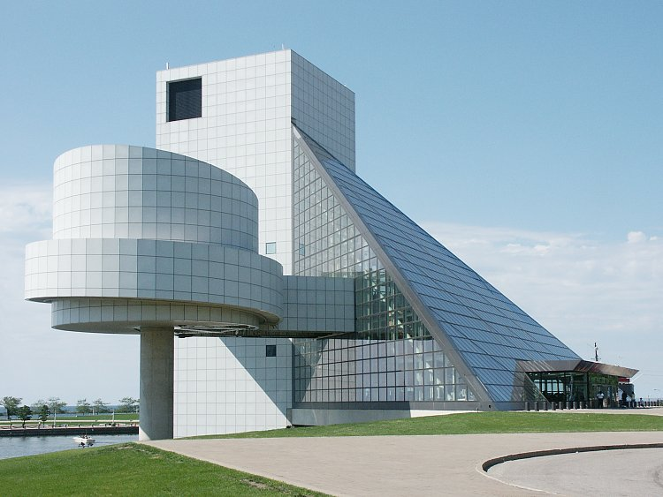

1. I. M. Pei, now considered a master of modern architecture, was born on April 26, 1917, in Canton, Guangzhou, China, I. M. Pei is one of the world's most famous architects. When he was 17 years old, he traveled to the United States, initially attending the University of Pennsylvania in Philadelphia before transferring to MIT, and then earning an M.A. from Harvard.

In the years following the death of President John F. Kennedy, Pei met with his widow, Jacqueline Kennedy Onassis, on the designs for his presidential library. Following the dedication of the Kennedy library, Pei continued to create wondrous buildings around the world, including the west wing of the Museum of Fine Arts in Boston (1980) and the Fragrant Hill Hotel in China (1983). In 1983, he was awarded the Pritzker Architecture Prize for his contributions to his field.

During this time, Pei also began work on revitalizing Paris's Louvre museum. The new, and controversial, entrance he created for the world-famous structure has since become one of the most iconic representations of his work. Pei had visitors descend into the museum through a large glass pyramid, which took them to a new level below the existing courtyard.

Pei continued to design impressive buildings during the 1990s, including the United States Holocaust Memorial Museum in Washington, D.C., and the Rock and Roll Hall of Fame in Cleveland, Ohio. Read more: http://www.biography.com/people/im-pei-9436323#synopsis

2. Video/Day 1: https://www.youtube.com/watch?v=xV-AfP1uDNk (3.33 mins.)

Video/Day 2:
http://www.pbs.org/wnet/americanmasters/i-m-pei-building-china-modern/1542/ (30 secs)

Photo Gallery for Day 2/PBS Modern Masters: http://www.pbs.org/wnet/americanmasters/i-m-pei-image-gallery-of-the-suzhou-museum/1570/#4

3. Standards: Kennedy Center (Federal) Art Standards, Visual Arts, Standard 5:
- Students compare multiple purposes for creating works of art
- Students analyze contemporary and/or historic meanings in specific artworks through cultural and aesthetic inquiry.
4. Questions:
a. How does Pei, per the Pritzker Architecture Prize Committee "draw together disparate people and disciplines to create an harmonious environment” in his architecture? Consider the Louvre.
b. What is unique about Pei’s work?

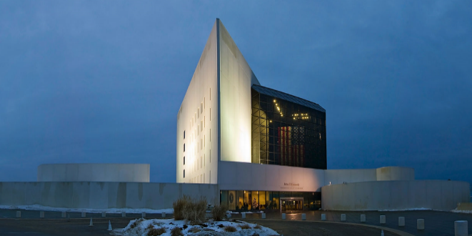
Kennedy Library, Boston, MA by I.M. Pei,
Architect
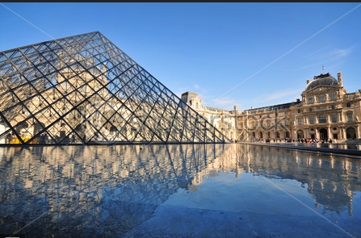
Louvre Museum, Paris by I. M. Pei, Architect

Monday, March 20th & Tuesday, March 21st CLEAN LINES, OPEN SPACES A VIEW OF MID CENTURY MODERN ARCHITECTURE
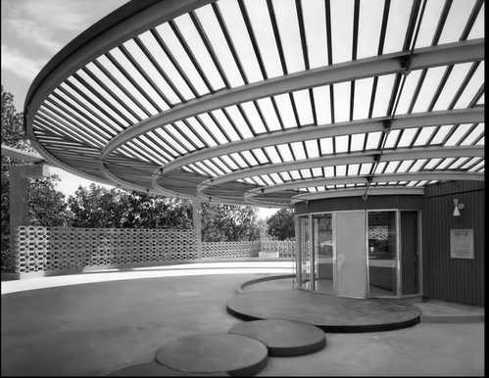

1. Overview – Includes a discussion of the Bauhaus, and the International Style, which looks the same regardless of the country.

2. Video - https://www.youtube.com/watch?v=K_YZbp-MmEo (56 mins./split across two days)

And further artwork: http://www.theartstory.org/movement-bauhaus-artworks.htm#pnt_2

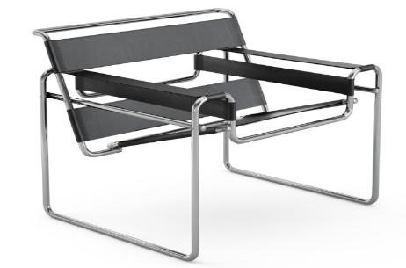
The Wassily Club Chair (Model B3), 1925 by Artist Marcel Breuer

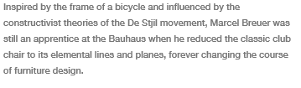
See Houzz Mid-Century Modern overview for nice images of mid-century modern homes:
https://www.houzz.com/ideabooks/15709218/list/roots-of-style-midcentury-modern-design

3. Standards -
4. Questions –
a. What was Bauhaus? See

Monday, March 27th & Tuesday, March 28 – Resonant Rings (A.K.A. – Building to Withstand Earthquakes)

1. Resonant Rings: This activity graphically demonstrates that objects of different sizes and stiffness tend to vibrate at different frequencies.

- SC Science Standard:
- Standard 6.S.1: The student will use the science and engineering practices, including the processes and skills of scientific inquiry, to develop understandings of science content.
- 6.S.1A.2 Develop, use, and refine models to (1) understand or represent phenomena, processes, and relationships, (2) test devices or solutions, or (3) communicate ideas to others.

- Exploratorium video: http://www.exploratorium.edu/snacks/resonant-rings
Audio: NPR, Ted Talk, How I Built This
http://www.npr.org/2010/01/14/122547242/haitis-buildings-werent-fit-to-withstand-quakes
- Questions:
  - Why do the rings have different resonant frequencies if they are shaken, and what does that mean for buildings in an earthquake?
  - How do the circles affect the building’s resonant frequencies?

Monday & Tuesday, April 3rd & 4th
Engineering Feats Around the World

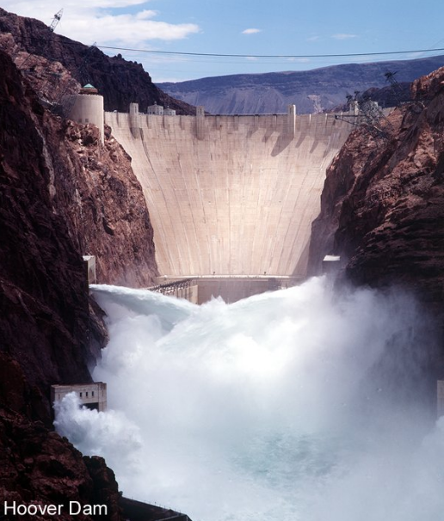

1. Overview of Hoover Dam – Engineering Marvel (taken from PBS’ American Experience/Hoover Dam): “It has been compared to the Acropolis of Ancient Greece and the Coliseum of Imperial Rome. Rising 726 feet above the raging waters of the Colorado River, it was called by the man whose name it bears “the greatest engineering work of its character ever attempted by the hand of man.” In fact, Hoover Dam reflected the engineering genius and design philosophy of the time. And, in the midst of the Great Depression, it was a symbol of hope for the dispossessed.

Winding through California’s richly fertile Imperial Valley, the Colorado River was wildly unpredictable—flooding in the spring, drying up in the summer. The only way to harness this indispensable resource was to build a dam, which in turn would provide badly needed electricity to the western states. It was a brilliantly conceived scheme, uniting public works and private enterprise. A giant construction company was formed by six previously smalltime contractors.
The engineering problems were stupendous, the solutions ingenious. Before work could start, the river had to be diverted. Four tunnels, each 50 feet in diameter (which today could accommodate a 747 without the wings), were drilled through the solid rock walls of the Black Canyon. Men called “high-scalers,” lowered in bosun’s chairs, stripped the canyon walls of loose rock.
For two years, workers poured concrete 24 hours a day, seven days a week. Working conditions were dangerous, pay was low, housing inadequate. But it was the Depression, and many were grateful to have work. Five thousand men and their families settled in the Nevada desert. There were two mess halls, each seating 600; the dishwasher was sixteen feet long.

In 1935 the job was finished under budget and ahead of schedule. But Hoover Dam also raised policy questions about the economic and environmental impact of large scale irrigation throughout the West.”
Read more at http://www.pbs.org/wgbh/americanexperience/features/introduction/hoover-introduction/
2. Engineering Standards: Grade 6_Science and Engineering Practices:
6.S.1B. Conceptual Understanding: Technology is any modification to the natural world created to fulfill the wants and needs of humans. The engineering design process involves a series of iterative steps used to solve a problem and often leads to the development of a new or improved technology.
3. Hoover Dam video:
History Channel (5 min video): http://www.history.com/topics/hoover-dam/videos
Scroll thru American Experiences (pictures of) The Men Who Built the Hoover Dam:
http://www.pbs.org/wgbh/americanexperience/features/photo-gallery/hoover/
American Experience/PBS – brief video (30 secs)
http://www.pbs.org/wgbh/americanexperience/films/hoover/player/
Timeline: http://www.pbs.org/wgbh/americanexperience/features/timeline/hoover/
4. Questions:
a. What were some of the unusual elements required to make this engineering marvel “work?”
b. Do some further research. How did the project’s electrical output helped build the ships and planes used in World War II?

April 17th & 18th – Engineering Feat: International Space Station

The International Space Station cost $100 billion to build and 100,000 in 15 nations. It ranks as one of the more unusual construction sites as it is located 220 miles above the Earth. The hazards faced by those carrying out maintenance go far beyond a falling hammer or nail gun injury as one tiny tear in the protective spacesuit means instant death.

2. Standard: SCIENCE AND ENGINEERING PRACTICES PERFORMANCE EXPECTATIONS PERFORMANCE INDICATOR S.1A.5: USE MATHEMATICAL AND COMPUTATIONAL THINKING (8th grade)

Systems and systems models: The National Research Council (2012) states that “Defining the system under study—specifying its boundaries and making explicit a model of that system—provides tools for understanding and testing ideas that are applicable throughout science and engineering” (p. 84). In this simple mechanical system, the interactions between forces and resulting changes in motion should be modeled using graphs or mathematical relationships.
3. Website:
- NASA Space Station website:
https://www.nasa.gov/mission_pages/station/main/index.html

- Engineering Feats of the World: http://www.cnn.com/2013/07/04/travel/engineering-feats/

- Tour the Space Station:
https://www.youtube.com/watch?v=WkYz43qALMU

4. Questions:
What does the model illustrate? • What conclusions can you make from the model? • How do certain factors influence one or more variables?

